SurePay Technical Documentation
This document present the parallel run plan and the architecture of the initial release of the new payment module (NPM) version 1.0. The approach is to have a cut-off date when the system will be put into operation alongside with the existing system.

System architecture design

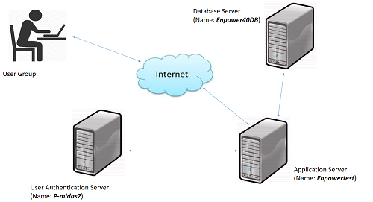

Datebase Server: The NPM database will be residence on Enpower40DB server.
Application Server: The NPM application files and user request will be processed and served back to the users through the internet. Microsoft IIS 8.0 application server on p-midas2 server machine will be responsible for these services. Also all the scanned and attached documents received from the application will be kept in the application folder called (“ApplicationDocuments”) in the same server machine (p-midas2).
User Authentication server: User authentication and authorization is one of the key features of the application. The domain authentication functionality is achieved by the ingestion of an existing web service running on p-midas2 server machine.

Application Dependencies
The NPM highly dependent on Enpower4.0 application for retrieval of customer details and also update of some information if required. The dependent objects are listed below;
Dependent database name: Enpowerv4
Tables Name:
- Insurer (Read)
- Employer (Read)
- Employee (Read & Write : Update the insurerID and bank details as adjusted on NPM)
- NextOfKin (Read)
- Contribution (Read)
- ContributionType (Read)
- Titles (Read)
- UnitPrice (Read)
- Banks (Read)
- Bank Branches (Read)
- TempPayment (Write)
Stored Functions:
- udfGetBalanceBySource
- GetFundBalanceByDate
- udfGetWithdrawalsBF

Dependent Services:
The service name is “webService” and is running Microsoft IIS on P-MIDAS Server machine. The service is used for user domain authentication
Release Note:
The following are the major currently available features for the initial release of NPM
- Auto generation of file number and application code
- Ability to log application any location and scan to add/remove application documents.
- Auto generation of SNR forms
- Automation of SP logs
- Ability to step backward or step forward the application process at any stage of the application.
- Auto generation of payment schedule to be sent to the PFC.
- Auto-sweep of payment schedule into EnpowerV4 for unit cancellation
- Auto generation of hardcopy Application slip and softcopy to be sent to the customer through email
- Ability to Log hardcopy application(i.e. application that will not be sent to the regulator through RMAS)
- Ability to generate RMAS benefit application schedule and confirmation module for approval before submission to the regulator through RMAS is done(i.e. application that will be submitted on RMAS)
- A user management module for role allocation and de-allocation.

The database diagram of the surePay database showing the tables and their relationships

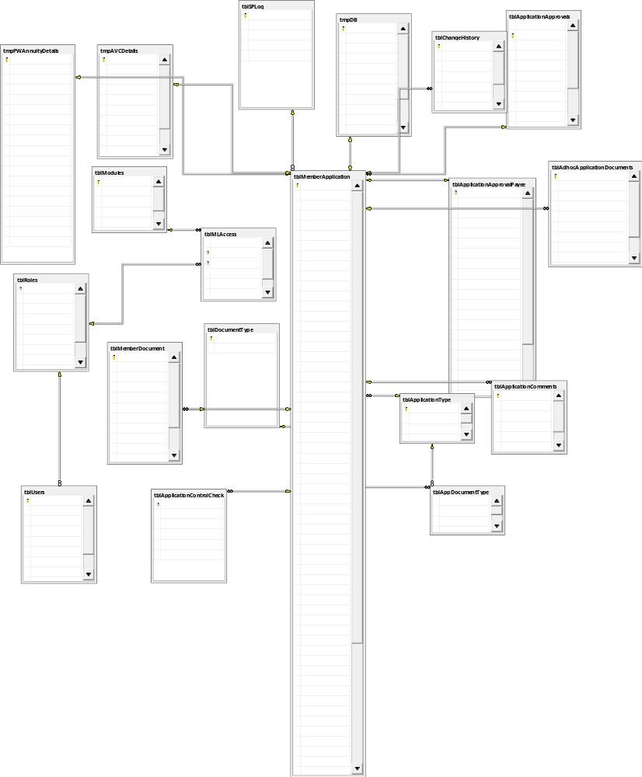
The database is sited on Microsoft SQL Server 2008 R2 with the name (SurePay). The database objects are listed below with a narration of objects respectively

Object Type | Database: SurePay
Table | awbr100 | It contain details for PW applications to be sent through RMAS
Table | awbr101 | It contain other details for PW applications to be sent through RMAS
Table | awbr200 | It contain details for NSITF applications to be sent through RMAS
Table | awbr300 | It contain details for legacy applications to be sent through RMAS
Table | awbr400 | It contain details for Enbloc applications to be sent through RMAS
Table | awbr500 | It contain details for 25% applications to be sent through RMAS
Table | awbr600 | It contain details for Death Benefit applications to be sent through RMAS
Table | awbr700 | It contain details for Annuity applications to be sent through RMAS
Table | awbr701 | It contain other details for Annuity applications to be sent through RMAS
Table | awbr800 | It contain other details for AVC applications to be sent through RMAS
Table | tblAdhocApplicationDocuments | It contains other document submitted with the application that are not originally required
Table | tblAppDocumentType | It contains list of all required documents required by different type of application
Table | tblApplicationApprovalPayee | It contains the list of all application approved by Pencom per batch Number
Table | tblApplicationComments | It contains the list of all comments logged with an application
Table | tblApplicationControlCheck | It keeps the activities of internal control checks on an application
Table | tblApplicationType | It keeps all the types of benefit applications
Table | tblChangeHistory | It contains the change history on the application
Table | tblDocumentType | It keeps all the document types for all application types
Table | tblMemberApplication | It contains all benefit application requests
Table | tblMemberDocument | It contains all submitted documents and the location of the scanned copies
Table | tblMLAccess | It contains all modules assigned a respective user roles
Table | tblModules | It contains list of all modules on the application
Table | tblRoles | It contains list of user roles
Table | tblSPLog | It contains all the list of autogenerated SPLog batch numbers
Table | tblUsers | It contains all the users that can access the application
Table | tmpAVCDetails | It’s a temporary table for use for processing AVC application
Table | tmpDB | It’s a temporary table for use for processing Death benefit application
Table | tmpPWAnnuityDetails | It’s a temporary table for use for processing both PW and Annuity benefit application
Table | tblSIPensioneer | This table keeps all the pensioners that are on our monthly programmed withdrawal platform
Table | tblSIRunHistory | This table keeps the generated standing instruction to the bank for the pensioners and the signatories approval status
StoredProcedure | sp_pm_getApplicationID | The procedure is responsible for the generation of applicationID serial number
StoredProcedure | sp_pm_getSPBatch | The procedure is responsible for the generation of applicationCode and SPLog batch number
StoredProcedure | sp_pm_applicationlifeCycle | This is responsible for the generation of application life cycle report on surePay
StoredProcedure | sp_pm_updatePaidApplication | This is responsible for the update of benefit application payment status(i.e. it stamp an application as PAID, if unit has been cancel on enpower)
StoredProcedure | sp_pm_CleanUploadedApplicationDocuments | This SP is responsible for the removal of duplicate document against a benefit application to enable viewing of the documents on SurePay
StoredProcedure | sp_pm_applicationreport | This is used for generation of report
StoredProcedure | sp_pm_applicationreportsummary | This is used for generation of report
StoredProcedure | sp_pm_getManagerReport | This is used for the generation of Manager’s dashboard data
Trigger | trgMemberApplicationUpdate | The object is responsible for keeping all change history on the application master table(tblmemberapplication)
Object Type | Datebase : EnpowerV4
Table | Employee | It contain employee records to update their Bank Details and Insurance Coy details
Table | TempTable | It contains the payment details exported from payment module to enpower for unit cancellation
Stored Functions | udfGetBalanceBySource | It’s being used to get customer’s contributions details
Stored Functions | GetFundBalanceByDate | It’s being used to get customer’s contributions details
Stored Functions | udfGetWithdrawalsBF | It’s being used to get customer’s withdrawal details
Report
CrystalReport | StandingInstruction | Standing Order Report
CrystalReport | SNR | Benefit Application Standard Notification Report
CrystalReport | ApplicationReciept | Benefit Application Report
CrystalReport | ApprovalPaymentSchedule | Benefit Payment Approval schedule to the bank
CrystalReport | ApprovalPaymentScheduleLPW | Benefit Payment Approval schedule to the bank for Programmed Withdrawal
CrystalReport | ApprovalPaymentScheduleAVC | Benefit Payment Approval schedule to the bank for AVC
External Libraries
EmailGateway.dll | \\p-midas2\MLive | Responsible for sending e-mail notification to the customer upon the completion of their benefit application
MailFilter.dll | \\p-midas2\MLive\ExchangeGateway\Release | Responsible to Filtering Successful RMAS AS-AT-WHEN validation e-mail from exchange server. This is dependent on sending SMS to the benefit payment applicants
Logger.dll | \\p-midas2\MLive | This is responsible for populating the log file with application meaning information
PaymentModuleDMSWindow.dll | Include in the application folder | This is responsible for the dropping of application documents on DMS
Document Management System Information
Object Store | LPPFA_BPD | This is the object store surePay’s documents are store on the document management system
Folder Name | SurePay | This is the name of the folder the documents are being saved in the object store
Application User ID | RMASSMS | This is the user name the application is using to integrate to DMS
Window Services
Service Name (DataExchange) | Server Name : RMS | The service is responsible for pupolation tblInvestmentExport_temp2 on NAV_DB with RF contribution upload from enpower. And also for the movement of backlog benefit application documents not already on DMS

tblInvestmentExport_Temp2

Software requirements
- Microsoft .Net Framework 4.5 : The framework that enable the application runs smoothly
- CrystalReportRuntime (64bit) : The software component that enable generation of PDF formatted reported
- Microsoft IIS 8.0: This is the web server that services users’ request.
- Microsoft SQL Server 2012: The database server the application was developed on.
- Microsoft Visual Studio 2012: This is used for code implementation.
Dependent Web Services
- wsUser.User (http://p-midas2/webServices/User.asmx): The service is used for the active directory user authentication.
- CrystalReportRuntime(CRforVS_redist_install_64bit_13_0_5): This software enables the generation and export of report from the application to PDF file.

The Application Entity Data Class: The entity class pulls data directly from the database for the application usage.

The Application Data Class Objects
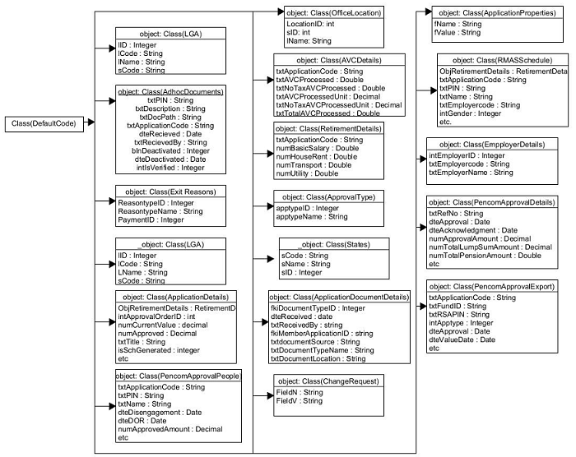

The Application Core implementation Class
Class Name | Core
Method Name | Type | Description

